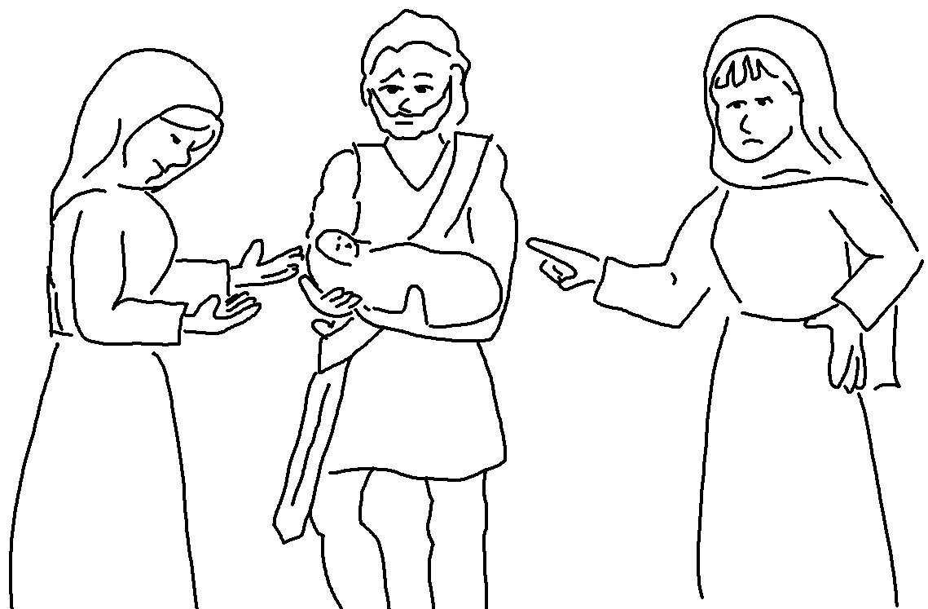

Respect and obey the _ _ _ _! This is the beginning of _ _ _ _ _ _.
To have understanding, you must know the Holy God. Proverbs 9:10 (CEV)
Fear of the _ _ _ _ is the foundation of _ _ _ _ _ _.
Knowledge of the Holy One results in good judgment. Proverbs 9:10 (NLT)

